Storing your Secure Print pin

- On your keyboard, hold down the Windows key and press the R key to open the Run window.
- In the Run window, type control printers and press the OK button.
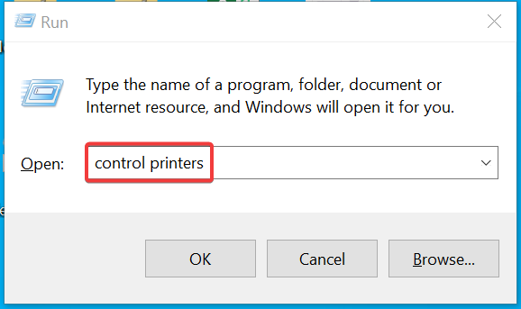
- A window should open with a list of installed Printers.
  - Right click on the Printer and select Printer Properties.
  - Select the Device Settings tab.
  - Click on the Settings(W) button to open the User Information Settings screen.
  - Choose a pin number to use when releasing your print jobs and enter it in the PIN field.
  - Remove the checkbox next to Confirm User Information When performing Secure Print.
  - Click the OK button to confirm your changes
  - Click Apply to save all changes.

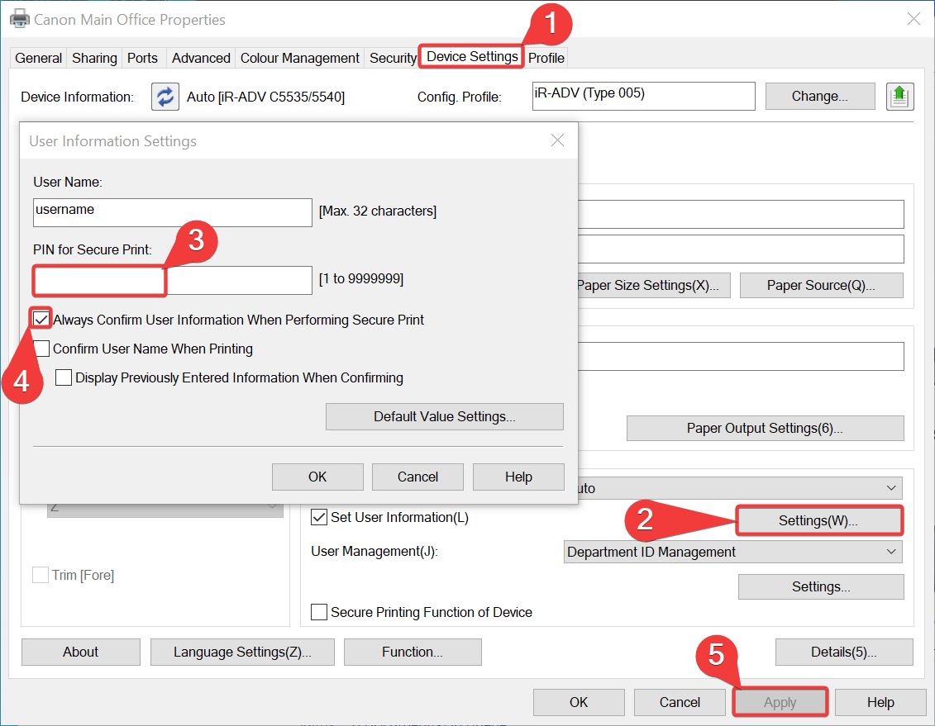
- Select the General tab
- Click the Printer Preferences

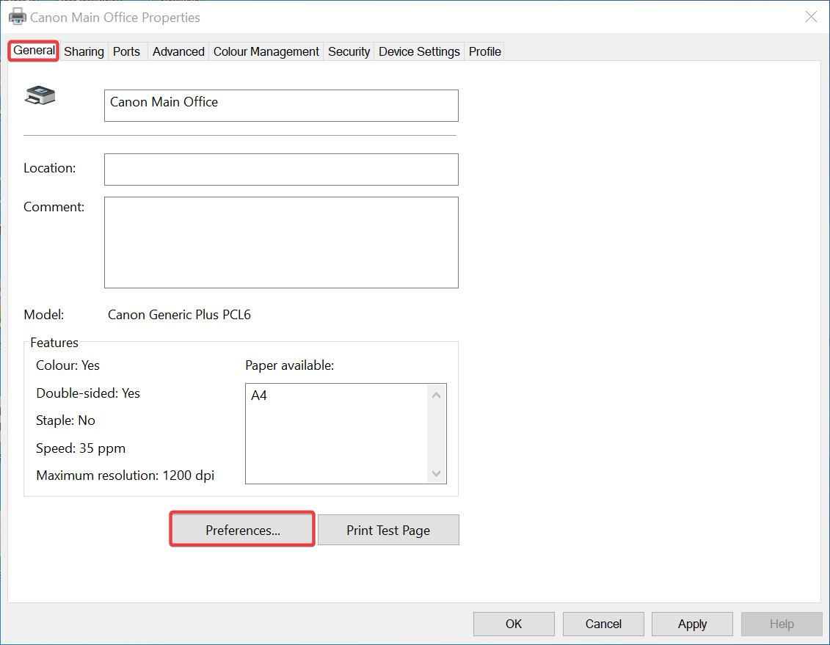

- Click the Output Method Dropdown and select Secure Print
- A dialog will pop up asking do you want to set the user information now.
- Click Yes.

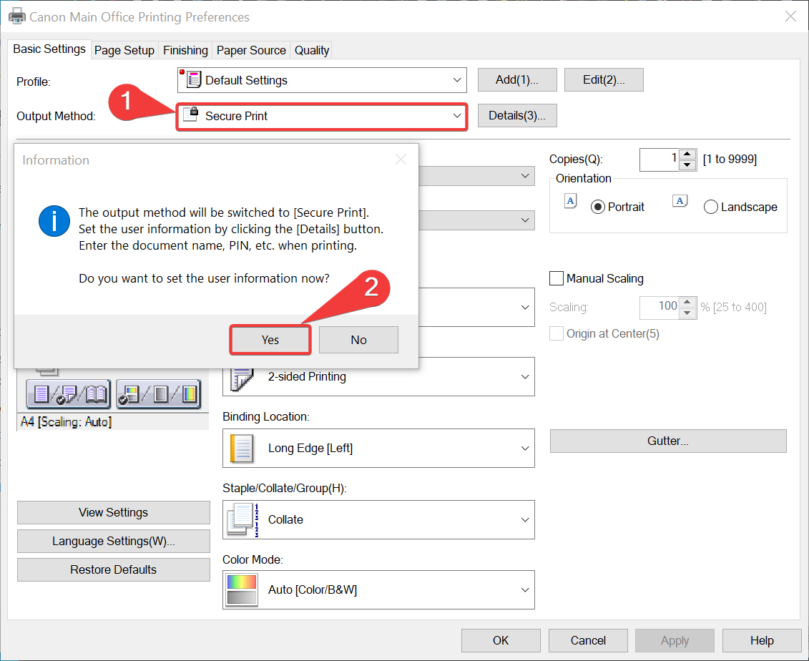
- The Secure Print Details window will popup this should already be filled in
- Click OK to confirm the changes.

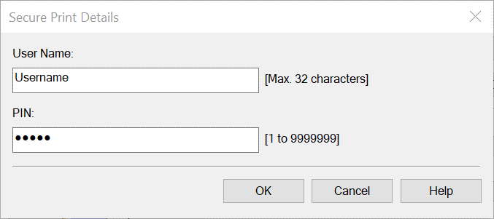
- Lastly just click apply in the bottom right.

Releasing your Secure Print at the Device.

- Select the Print icon with the lock on it.
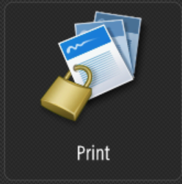

- Select the job you want to print and press the Secured Print button.
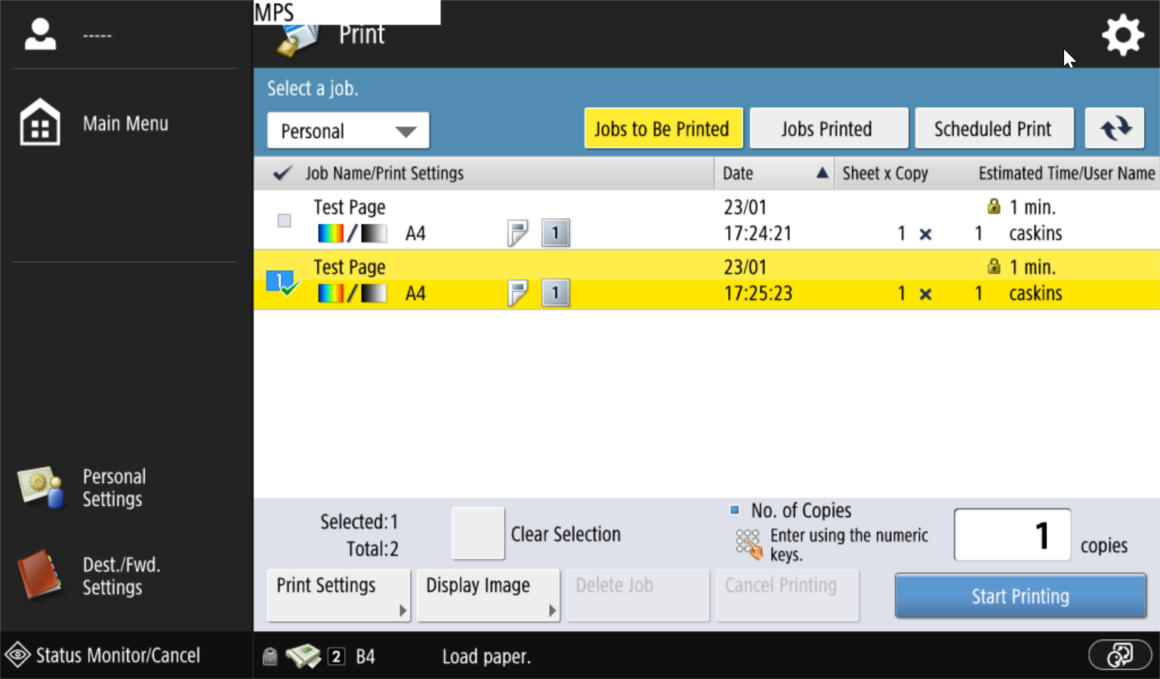
- Enter the Pin Number you previously stored in the driver.

